Using Venn Diagrams
Purpose and Method
A Venn diagram is a graphic organizer that helps students understand relationships between two or more things. Venn diagrams can help students cement knowledge they have already acquired as well as allow them to see how knowledge about a specific concept can be related to other concepts.
Bloom’s taxonomy scaffolds thinking from lower to high levels. Through research, educators have come to understand the importance of moving students’ thinking to higher levels. Higher-level thinking encourages ownership, deepens and broadens understanding of the concepts, and better prepares students for more advanced learning and real-life application.
Using Venn diagrams encourages thinking on multiple levels. First, students name or recite information learned, a low-level task. Then a Venn diagram requires students to analyze information by determining if it is similar to or different from something else. This task of analysis moves students into higher-level thinking.
Two interconnected circles are the most common type of Venn diagram. You pose two concepts or items for the students to consider. Each concept or item is assigned to a circle. In the first circle, in the portion not overlapping the second, the students identify unique characteristics of the corresponding item or concept. Then, in the second circle, in the portion not overlapping the second, the students identify unique characteristics of the second item or concept. The middle section, where the circles intersect or ovelap, is where the students identify the elements that the two items share in common—the similarities. See figure 1.
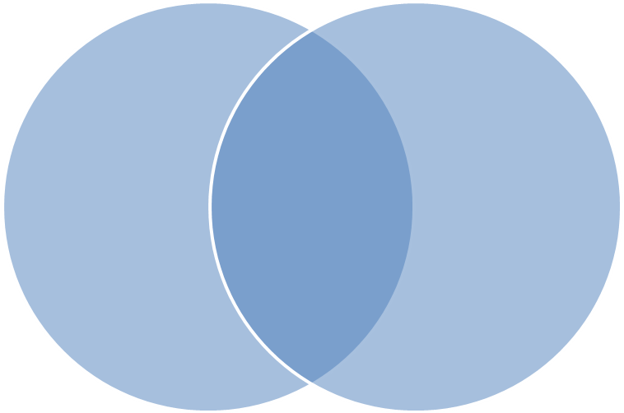
Figure 1

For example, compare an orange and an apple. See figure 2.

Similarities
Fruit
Taste sweet
Provide essential vitamins
Can produce juice
Grown on trees

Figure 2

Orange
Color is orange
Grown in the south
Need to peel

Apple
Color is red
Grown in the north
Can eat outer skin

It is possible to create more in-depth Venn diagrams, where more than two things are being compared: see figure 3 for an example. Note that adding more overlapping circles allows you to note similarities between just each pair of overlapping circles as well as between all the circles. However, comparing more items will require your directions to clarify what characteristics you are asking the students to compare. For example, if you add a third or fourth fruit to the example above, you may want to limit the characteristics to just color, or just to the way that each fruit is grown. Without clarification, the diagram can become too large, and key items to compare may become lost. In this case a graphic device other than two intersecting circles may be a better choice.

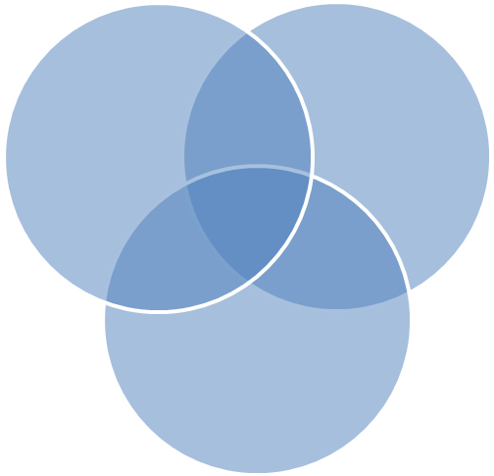
Figure 3

Summary of Steps
- Determine what two (or more) concepts you would like the students to compare.
- Create intersecting circles on the board, a projector transparency, or paper.
- Ask the students to think about and complete some similarities or differences on their own first, to be shared with the class.
- Ask the students to report similarities and differences to the rest of the class. It is important for the students to explain their thinking. Hearing peers explain their thinking is helpful for other students who may not understand.
If you use a SMART board, an alternative learning technique using Venn diagrams is to start by making lists on the board of characteristics of the two items. Then draw the intersecting circles and label each circle with one of the items. Go through the lists you created, item by item, and ask the students where they would put each item. With your SMART board pen, click and drag the item from the list into the appropriate location. Again the key element is for the students to explain why they would put it under the specific category. Hearing peers explain their thinking is helpful for other students who may not understand.

