The Young Woman
(Teacher Resource)

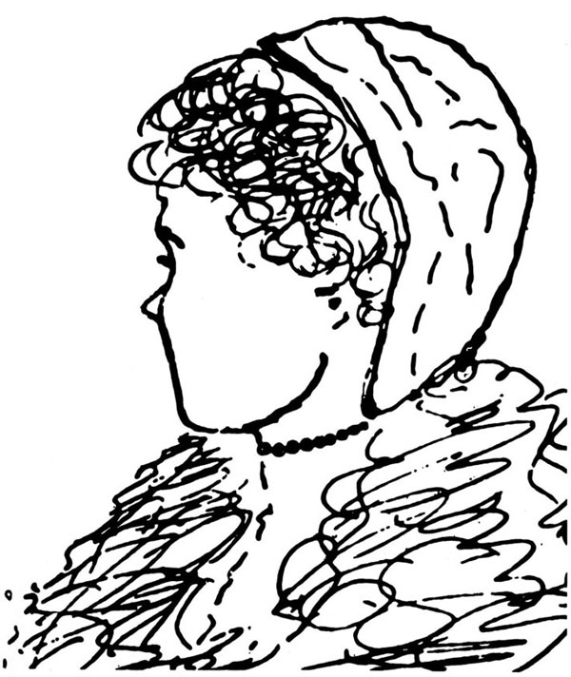

(From The Seven Habits of Highly Effective People: Restoring the Character Ethic, by Stephen R. Covey [New York: Free Press, 1989], pages 25–26. Copyright © 1989 by Stephen R. Covey. Used with permission.)

