Traveling with Abraham

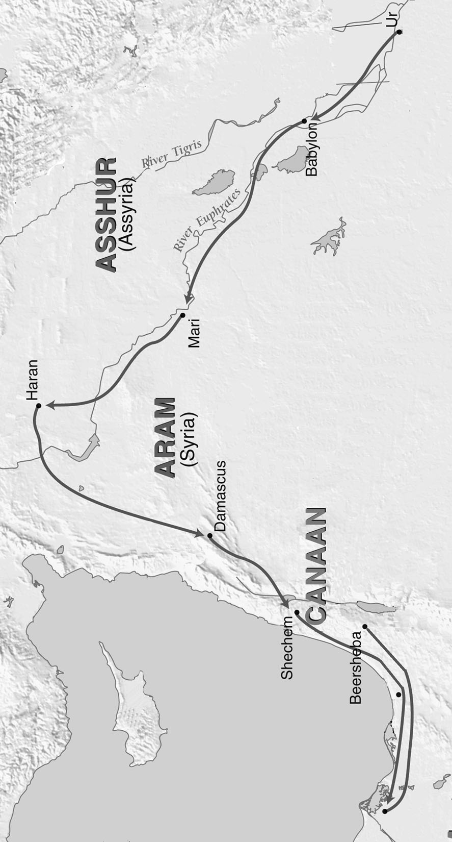

Start

Finish