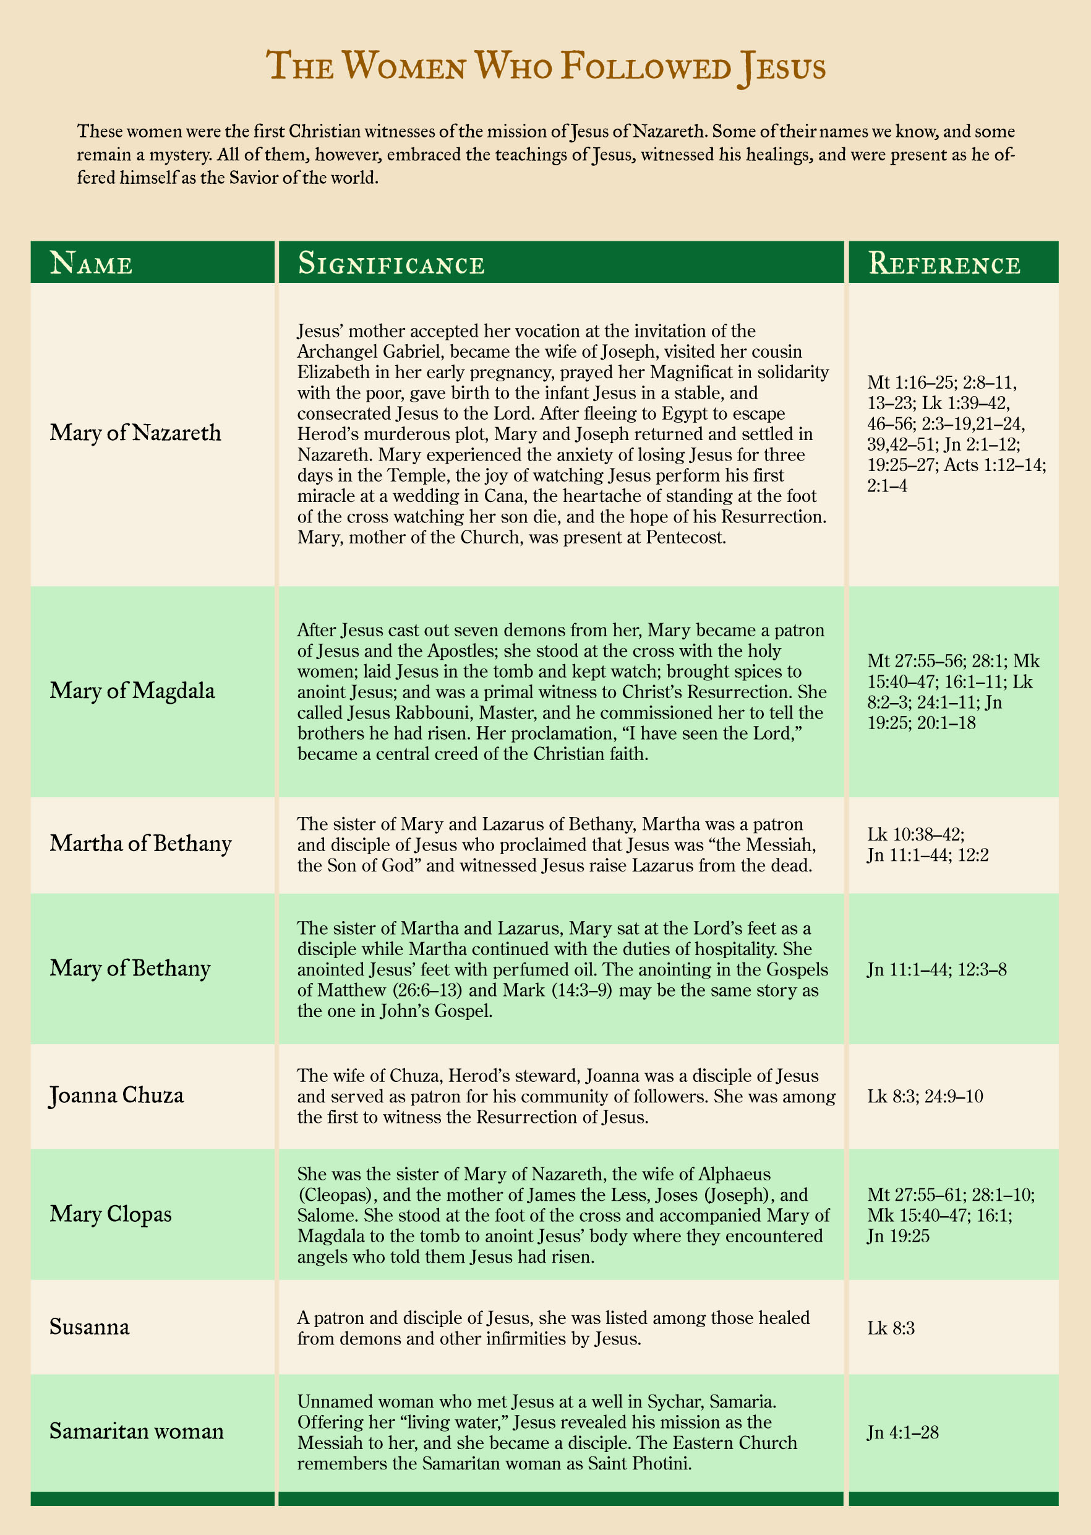

This chart is from the *Saint Mary's Press® College Study Bible* (2006), page c28.