How to Upload Students

Download this template so you can get your class list in the correct format: CSV Upload Students Template

You will need to create a separate csv file for each class within a grade level. Here are a few tips to make it easier:
Row 1: Keep all of the data in row 1
Rows 2+:
a) Fill in your students first & last name.
b) Delete <email> But keep the word “email” at the head of column C.
c) Add a username for each student in column D. Your standard username will be: FirstLast1 (example: SamJohnson1). Please note, if your student has a hyphen or any special characters in their name, please remove the special character from the document. The program does not work with any special characters. For example Maria-Anna Martinez should be entered MariaAnna (Column A) Martinez (Column B) and MariaAnnaMartinez1 (Column D)

It should look something like this when you are finished:
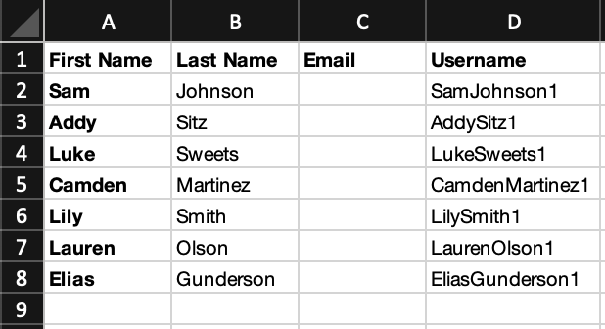
Save your list as a .csv file. If you have more than one class, save a separate list for each class.

- Go to mlearn.smp.org and log-in with your username and password.
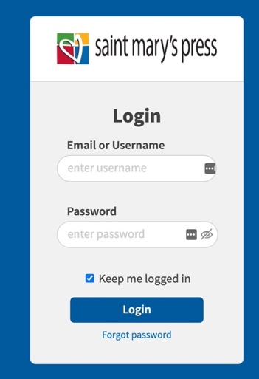

- Then click “go to admin area” (or skip this step if it takes you right in to screen #3)
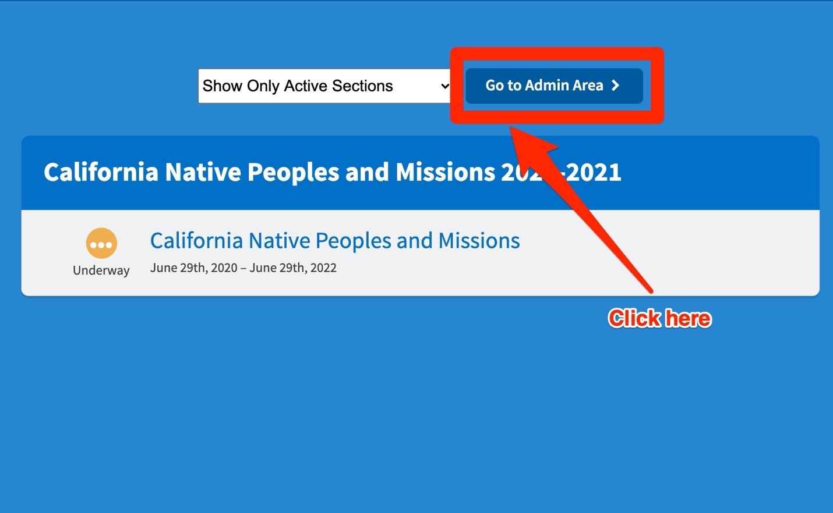

- Find your course (California Native Peoples and Missions 2020-2021) and click “manage sections”
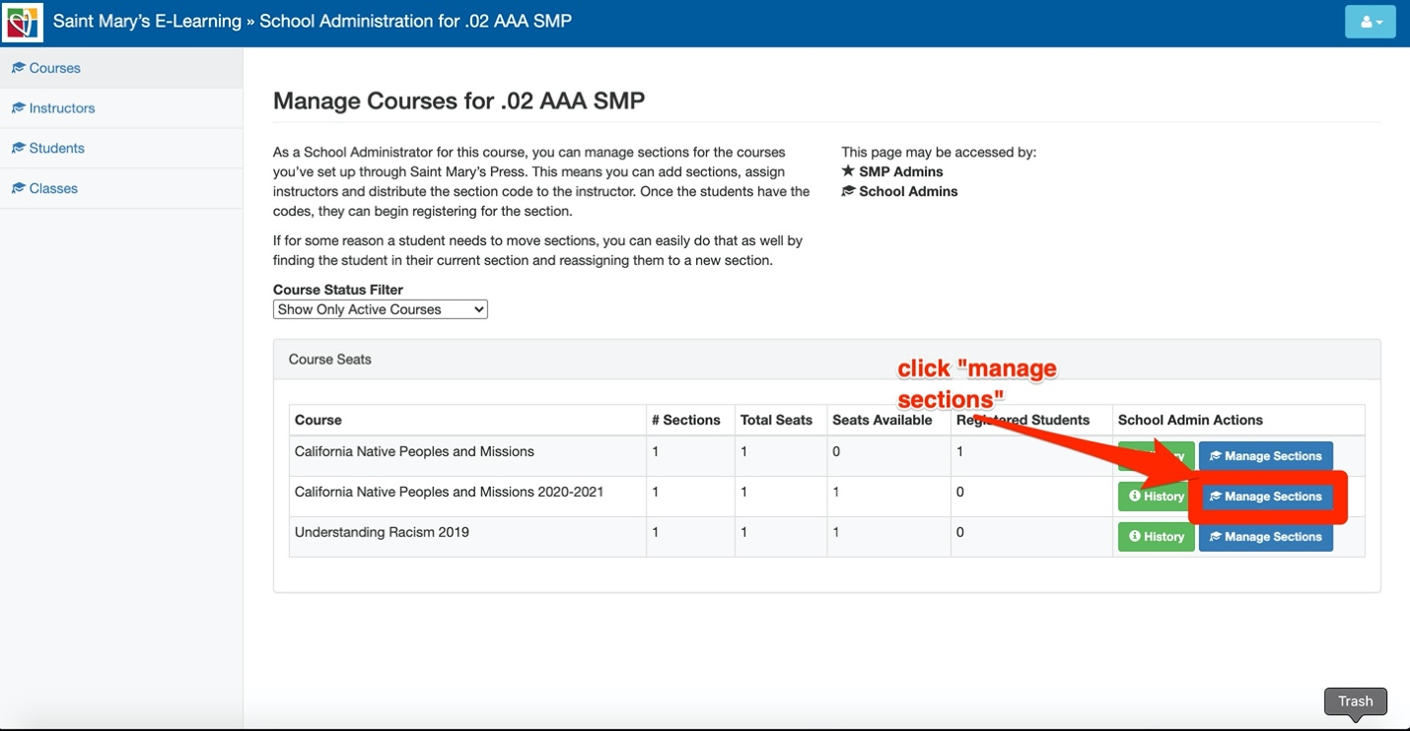

- Then click on the section name (if you have more than one class be sure to open the “add a class” doc so you can add your additional class before you get too far).
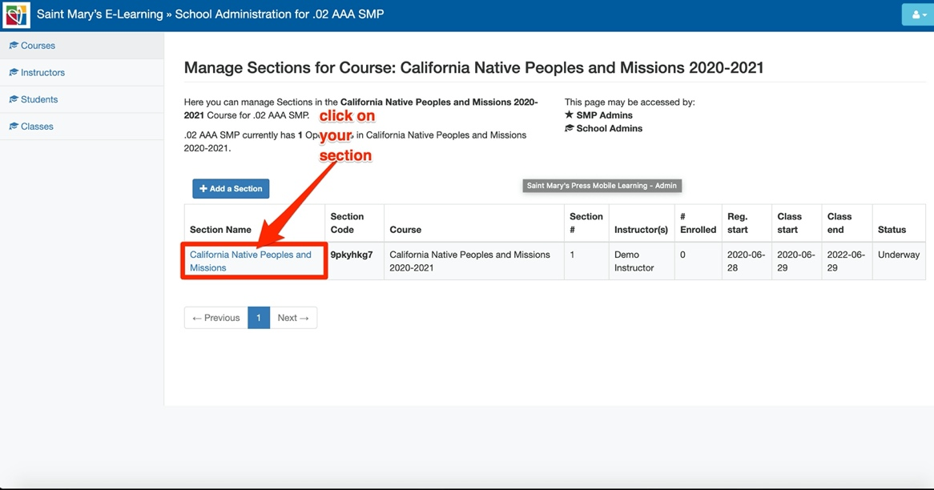

- Confirm this is the correct instructor, if so, move to #6, if not, open the “add a teacher” document to update.
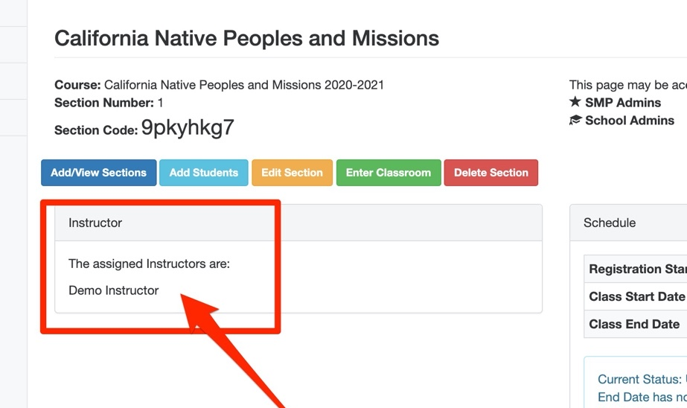

- Then click on “add students”
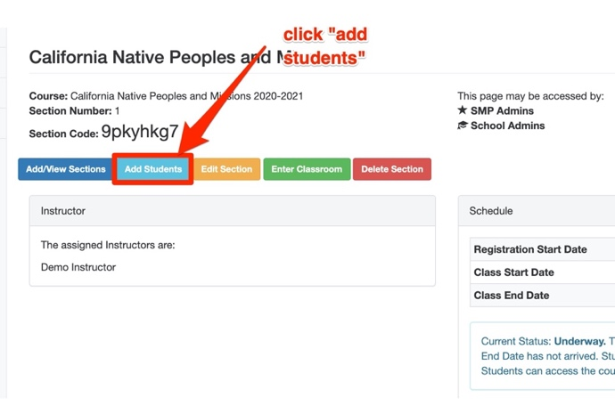

- Then click “browse” – then find the class list you created at the beginning, select it and hit open (make sure it’s a csv or it won’t work).
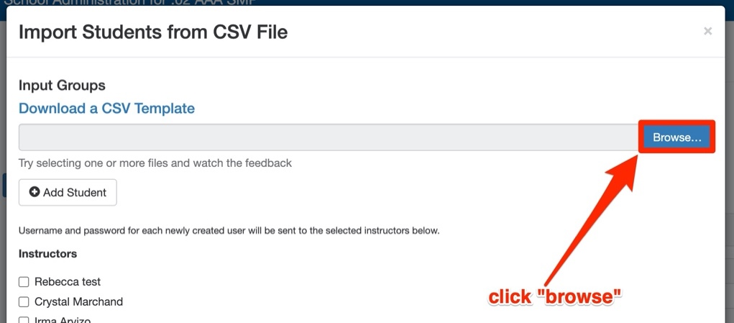

- It will look like this, skim through and make sure it all looks right – if you get an error saying the username already exists, just change the 1 in the username to a 2 or 3 and that should solve it.
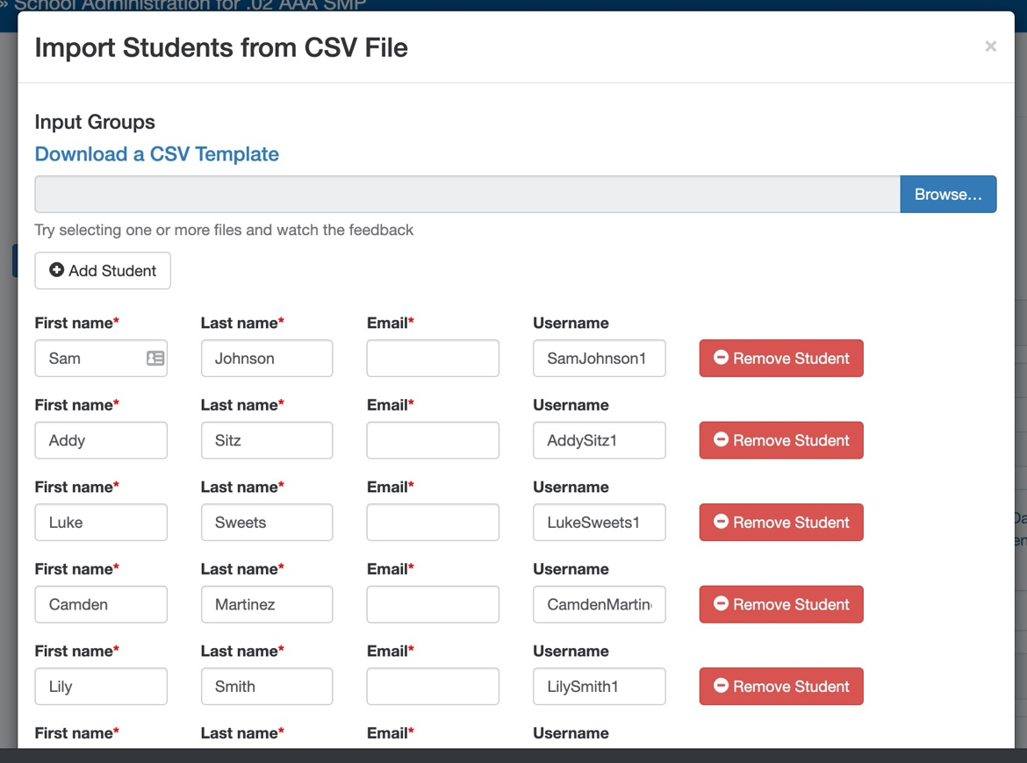

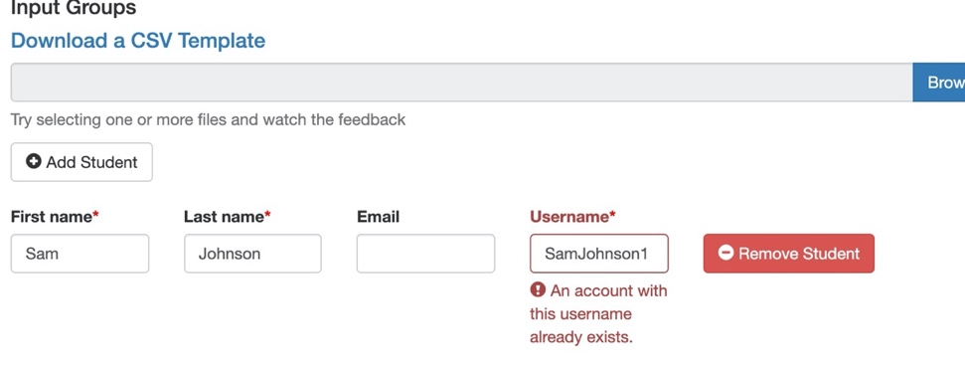

- Then, scroll down and select your name under instructors before you hit “import students” – this will send you an email with a list of each student’s username and password to distribute to the students.
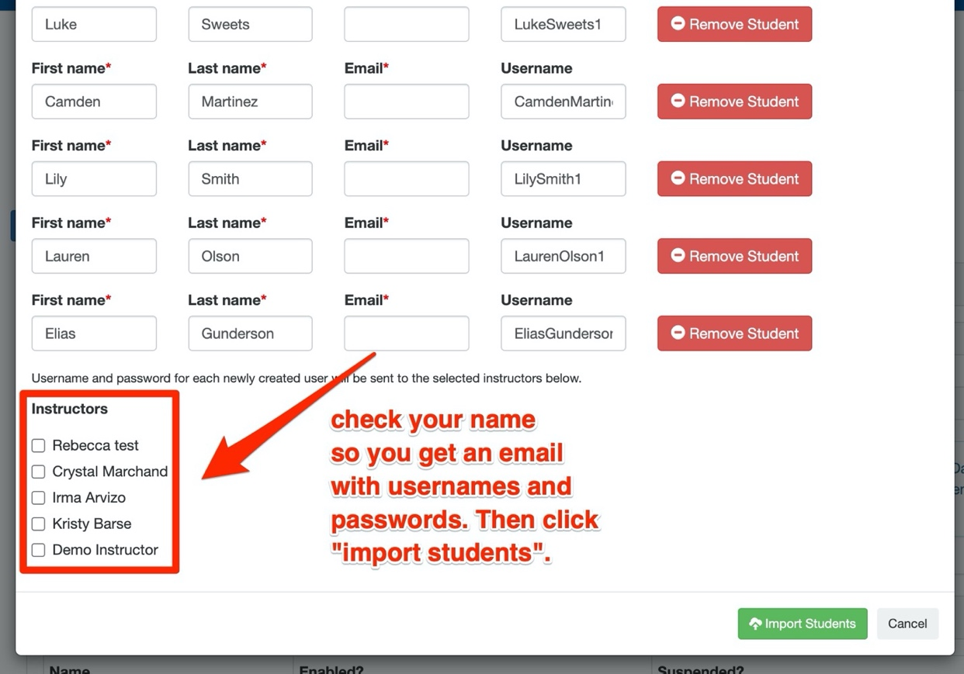

- You’ll see the “success” message once you’ve uploaded. You can now hit the x in the upper right corner if you are finished. If you have more students to upload you can go to “add student” and add one at a time. This will add more students to this same class. If you have a second class to upload – walk through these steps again for a different section.

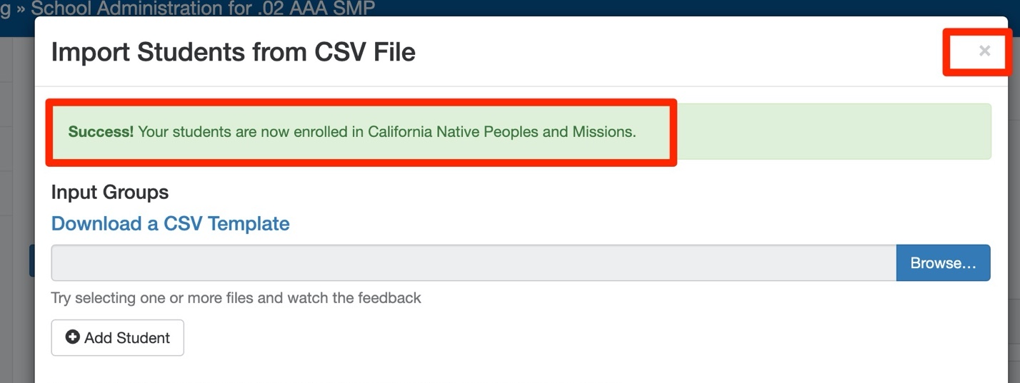

- Hit “refresh” on your browser and the students will appear at the bottom of that page:
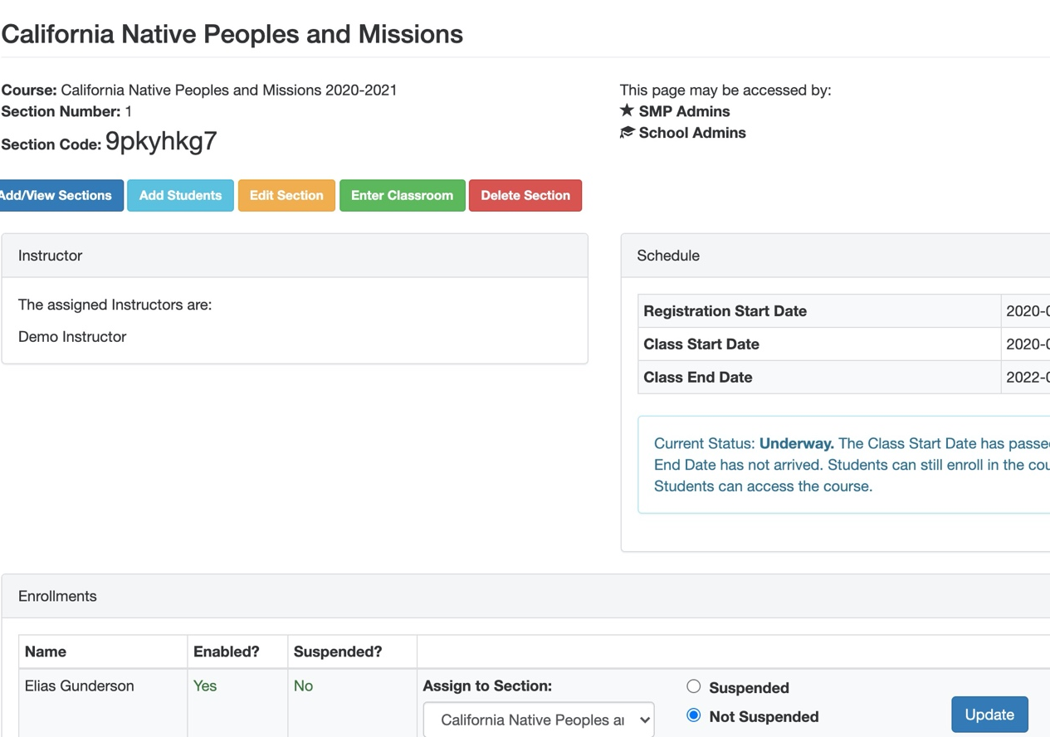

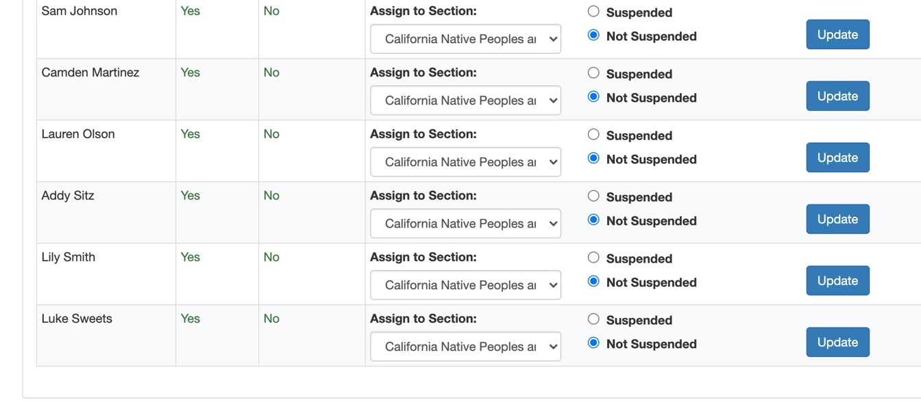

- Your students are now uploaded – you should get an email with username and passwords – if your email gets stuck in spam or you don’t see it- the passwords generate as FirstnameLastname – so Lily Smith’s password would be LilySmith – Luke Sweet’s password would be LukeSweet. Get the username and passwords to the students. They will want to bookmark mlearn.smp.org – if they click “keep me logged in” they won’t have to type it in each time.
- Please note – you may see a note that says “you have more registered students than total seats” – and notice a negative number, you can ignore that – we will bill you for the total number of students and adjust the total seats at that time. You can ignore this.
