Chapter 7 Activity:
Humankind and Original Sin
Complete the crossword puzzle.
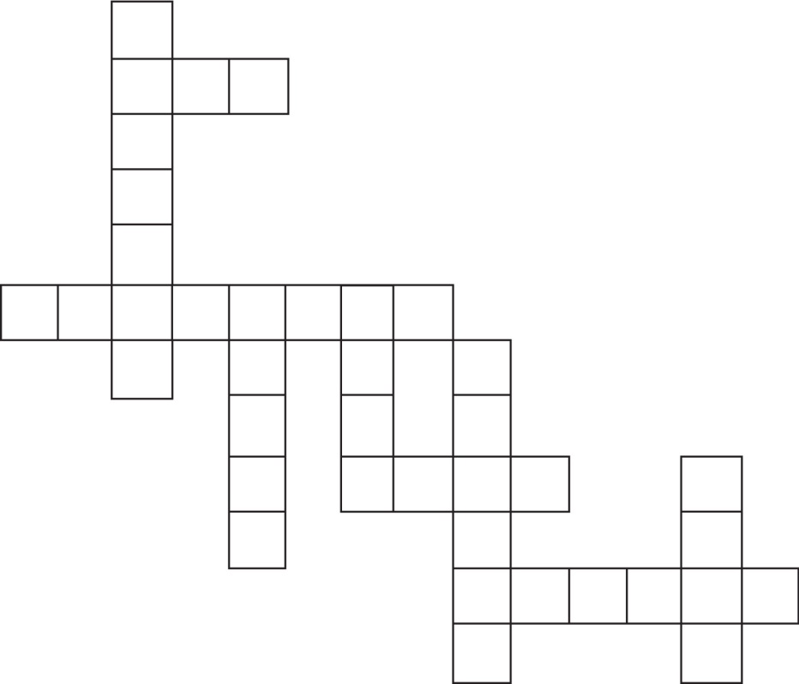
8
9
6
7
5
4
3
2
1
Across
2. The name ______________________ comes from the Hebrew word for “life.”
3. ______________________ Sin is the sin that our first parents committed, and the sinful condition that all people have from birth.
7. Original Sin affects every person except Jesus and ______________________.
9. A temptation makes something ______________________ seem fun or good to do.
Down
1. The Book of ______________________ contains two Creation stories.
4. Every human being is made in the ______________________ of God.
5. The name ______________________ comes from the Hebrew word for “man.”
6. ______________________ is the model of the perfect human being.
8. All people are living beings made up of both a physical body and an immortal, _____________.

