Chapter 4 Activity:
Symbols for the Blessed Trinity
According to tradition, Saint Patrick used a shamrock to represent the Blessed Trinity—the one God in three Divine Persons. The following symbols, the triquetra (TRY-kwetra), on the left, and the triangle, are also symbols for the Trinity. On the lines below, explain how each of these symbols is a good representation for the Trinity.
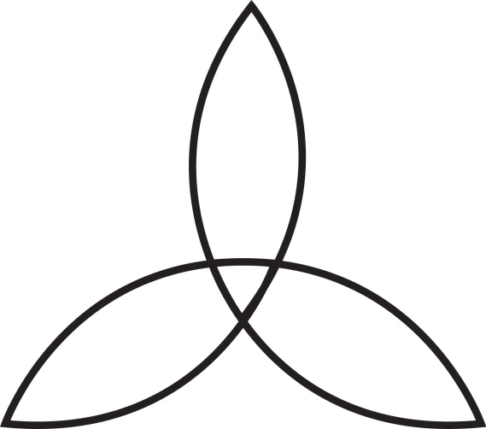
___________________________________________________________________________________
___________________________________________________________________________________
___________________________________________________________________________________
___________________________________________________________________________________
___________________________________________________________________________________
A Prayer to the Trinity
Solve the following cryptogram to decipher a simple prayer in which we recognize the mystery of one God in three Divine Persons.
