Chapter 5 Activity:
Finding God’s Guidance in the Bible
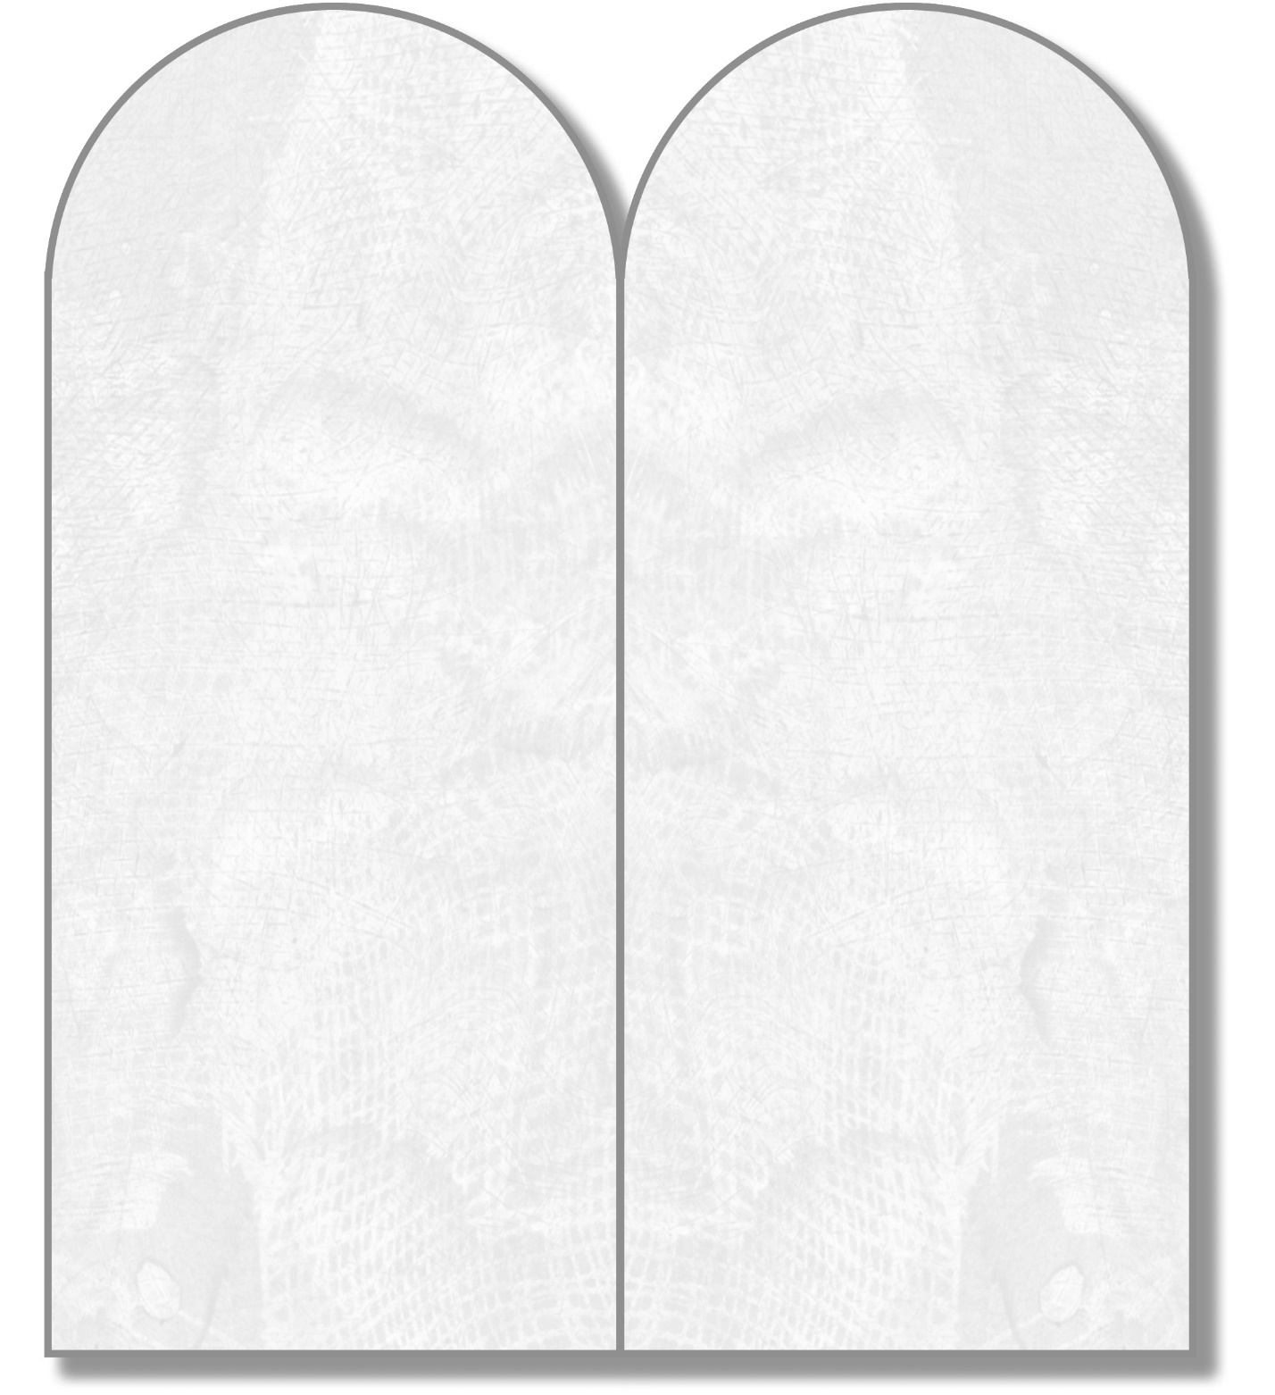
6. Exodus 20:1–17 (the Ten Commandments)
7. Judges 2:11–19 (God sends judges)
8. 1 Samuel 8:1–22 (the people ask for a king)
9. 1 Samuel 16:1–3,8–13 (David is made a king)
10. 2 Kings 25:1–12 (destruction of the Temple)
11. Psalm 23:1–6 (The Lord is Our Shepherd)
12. Wisdom 6:1–11 (the responsibility of rulers)
13. Jeremiah 1:4–10 (call of the prophet Jeremiah)
14. Isaiah 52:13, 53:4–11 (God’s Suffering Servant)

How did God help or challenge his people?
How did God show that he was pleased (or displeased) with his people?
What did God say or do to express how he wanted his people to live?
In what section of the Bible do each of the following passages appear—the Pentateuch, the historical books, the wisdom and poetry books, or the prophets?
1. Genesis 1:26–31 (God creates)
2. Genesis 6:5–8, 9:8–15 (Noah)
3. Genesis 12:1–5 (Abraham)
4. Exodus 3:1–17 (Moses—I AM)
5. Exodus 13:20—14:30 (God parts the Red Sea)

